Lab # 08

System Programming



Teacher | Bibi Areej Khan
Student Name | Muhammad Ahmad Khan
Registration No | 23JZBCS0238

Department of CS&IT
University of Engineering and Technology Peshawar
(Jalozai Campus)

Lab No. 8 — I/O in Linux

1. Objectives
- To understand the UNIX/Linux I/O model
- To use low-level system calls: open(), read(), write(), close()
- To understand file descriptors (STDIN_FILENO, STDOUT_FILENO)
- To create processes using fork()
- To implement parallel file copying using multiple processes
- To perform input/output redirection manually (like cat command)

2. Theory
Linux follows a uniform I/O model, meaning all I/O devices (files, keyboard, screen) are treated as files.

Key Concepts

1. File Descriptors
- 0 → Standard Input (STDIN_FILENO)
- 1 → Standard Output (STDOUT_FILENO)
- 2 → Standard Error (STDERR_FILENO)

2. System Calls

open()
- Opens a file and returns a file descriptor
- Example:
int fd = open("file.txt", O_RDONLY);

read()
- Reads data from a file descriptor into a buffer
int n = read(fd, buffer, size);

write()
- Writes data from buffer to file descriptor
write(fd, buffer, n);

close()
- Closes the file descriptor
close(fd);

3. Process Creation (fork())
- Creates a new child process
- Child gets a copy of parent memory
- Used here for parallel file copying

4. Parallel Processing
- Multiple child processes run simultaneously
- Each process handles copying one pair of files

3. Task 01 — Parallel File Copy

Code (task1.c)
#include <unistd.h>
#include <fcntl.h>
#include <sys/wait.h>

int main(int argc, char *argv[])
{
if ((argc - 1) % 2 != 0)
{
write(1, "Error: Even number of files required\n", 38);
return 1;
}

for (int i = 1; i < argc; i += 2)
{
if (fork() == 0)
{
int src = open(argv[i], O_RDONLY);
int dest = open(argv[i + 1], O_WRONLY | O_CREAT | O_TRUNC, 0666);

char buf[1024];
int n;

while ((n = read(src, buf, 1024)) > 0)
{
write(dest, buf, n);
}

close(src);
close(dest);
return 0;
}
}

while (wait(0) > 0);

return 0;
}

Explanation
- Program checks if number of files is even
- Each pair represents:
source → destination
- fork() creates a child process for each pair
- Each child:
  - Opens source file
  - Creates destination file
  - Copies data using buffer
- Parent waits for all children using wait()
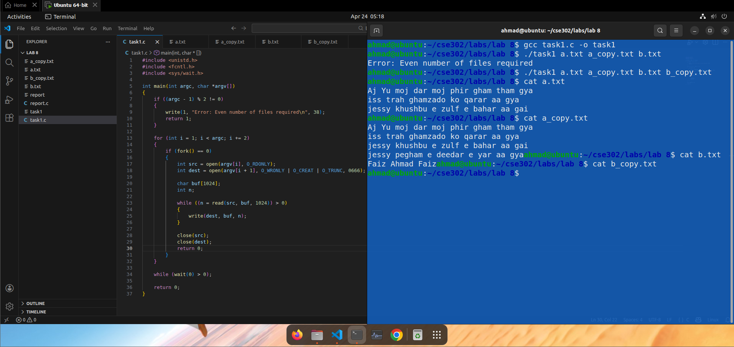

4. Task 02 — CAT Utility

1. Keyboard → Screen

Code (cat1.c)
#include <unistd.h>

int main()
{
char buf[100];
int n;

while ((n = read(0, buf, 100)) > 0)
write(1, buf, n);

return 0;
}

Explanation
- Reads input from keyboard (fd = 0)
- Writes directly to screen (fd = 1)
- Works like basic cat
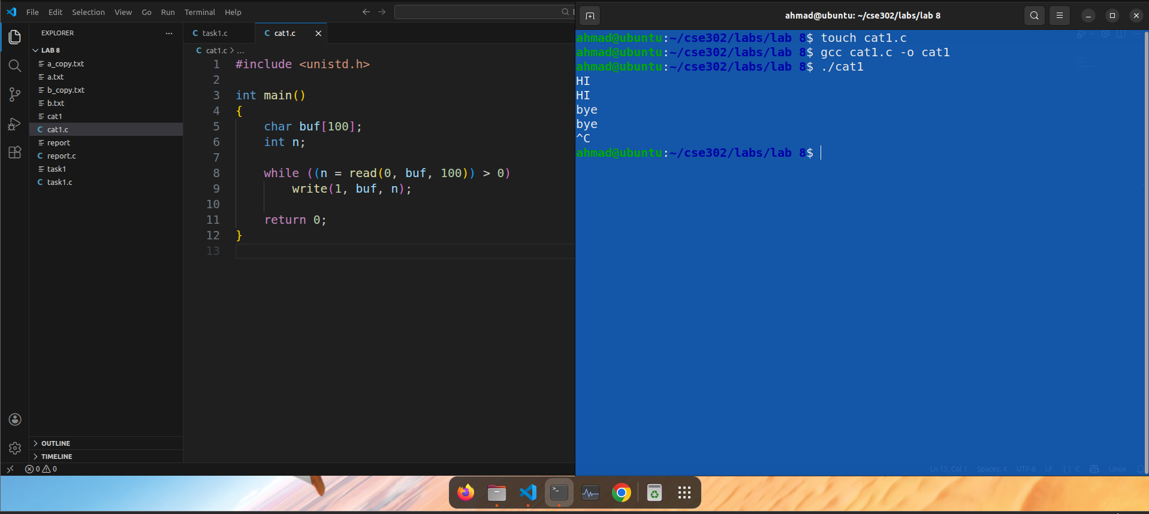

2. Keyboard → File (Custom Cat)

Code (cat2.c)
#include <unistd.h>
#include <fcntl.h>

int main()
{
int fd = open("file1.txt", O_WRONLY | O_CREAT | O_TRUNC, 0666);

char buf[100];
int n;

while ((n = read(0, buf, 100)) > 0)
{
if (buf[0] == 's')
break;

write(fd, buf, n);
}

close(fd);
return 0;
}

Explanation
- Reads from keyboard
- Writes into file1.txt
- Stops when user enters 's'
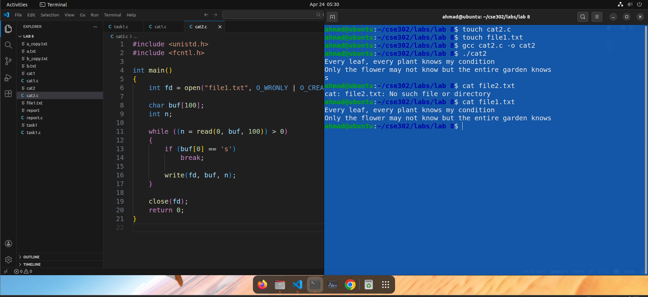

3. File → Screen

Code (cat3.c)
#include <unistd.h>
#include <fcntl.h>

int main()
{
int fd = open("file2.txt", O_RDONLY);

char buf[100];
int n;

while ((n = read(fd, buf, 100)) > 0)
write(1, buf, n);

close(fd);
return 0;
}

Explanation
- Opens file in read mode
- Displays contents on screen
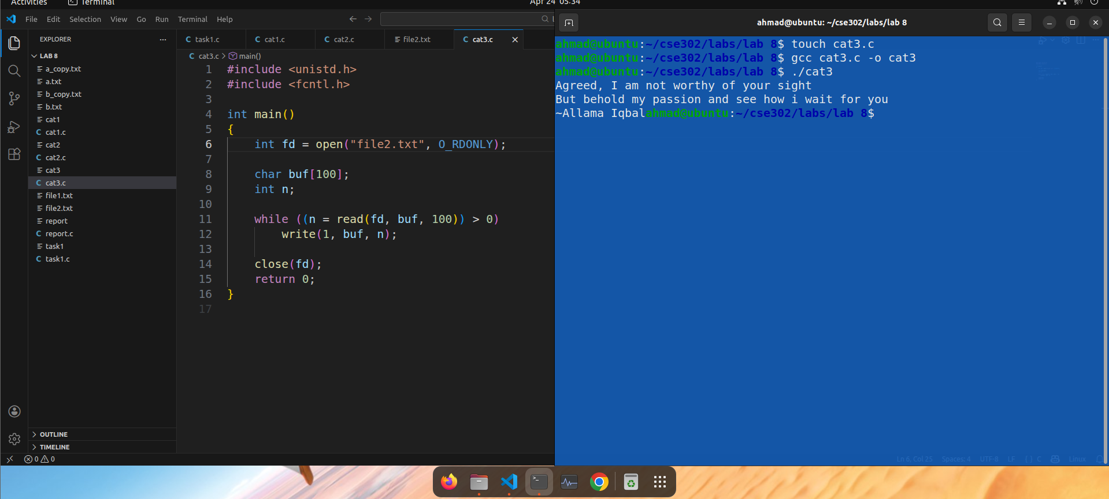

4. File → File

Code (cat4.c)
#include <unistd.h>
#include <fcntl.h>

int main()
{
int src = open("f1.txt", O_RDONLY);
int dest = open("f2.txt", O_WRONLY | O_CREAT | O_TRUNC, 0666);

char buf[100];
int n;

while ((n = read(src, buf, 100)) > 0)
write(dest, buf, n);

close(src);
close(dest);
return 0;
}

Explanation
- Reads data from f1.txt
- Writes it into f2.txt
- Works like:
cat f1.txt > f2.txt

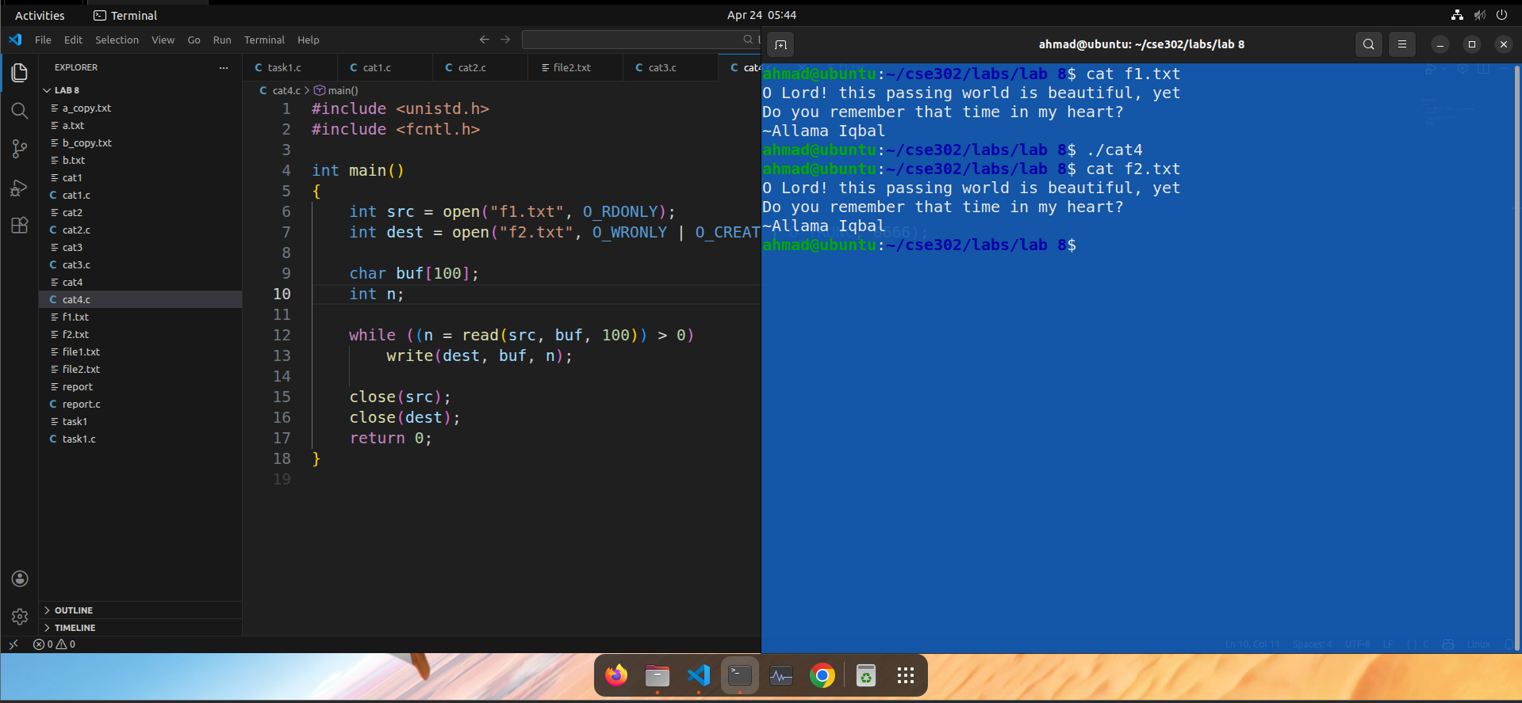5. Conclusion
- Linux treats all I/O operations uniformly through file descriptors
- Low-level system calls (open, read, write) provide fine control over I/O
- fork() enables parallel execution, improving performance for tasks like file copying
- The cat utility demonstrates how input/output redirection works internally
- This lab reinforces understanding of process management and file handling in Linux

